**Question 2: -**

**Copy the plot diagram in the word document and interpret the output.**

**Answer: -**

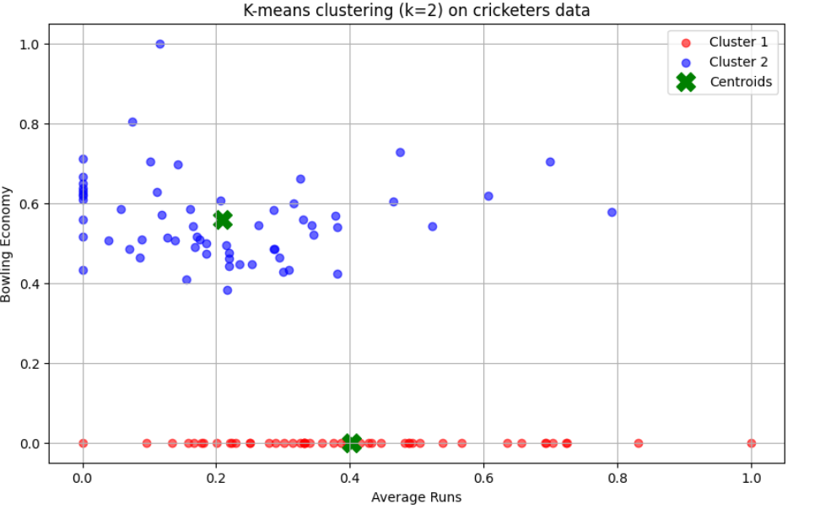

This plot represents the output of a K-means clustering analysis on cricketers' data, using k=2k = 2k=2 clusters. Here’s a breakdown of the elements in the plot:

1. **Clusters**:
   * The plot shows two clusters of cricketers based on two variables: *Average Runs* and *Bowling Economy*.
   * **Cluster 1 (Red)** represents one group of cricketers who tend to have very low *Bowling Economy* values, indicating a group of more economical bowlers.
   * **Cluster 2 (Blue)** represents another group with higher *Bowling Economy* values, possibly indicating less economical bowlers.
2. **Centroids (Black X markers)**:
   * The centroids are marked in green, representing the average position for each cluster on the plot.
   * The centroids indicate where each cluster's "center" lies in terms of *Average Runs* and *Bowling Economy*.
3. **Axes Interpretation**:
   * The x-axis represents *Average Runs* scored.
   * The y-axis represents *Bowling Economy*.

**Insights:**

* The clusters show a distinct separation between players with lower and higher bowling economies.
* Cluster 1 (red) has most of its points near zero on the *Bowling Economy* axis, suggesting these players have lower economy rates.
* Cluster 2 (blue) has a broader spread on the *Bowling Economy* axis, indicating variability in their economy rates.

This clustering may be helpful in distinguishing cricketers who excel in limiting runs (low economy rate) from others.

**Question 3: -**

**copy the plot diagrams in the word document, and comment on which is better clustering (and reasons) based on visualization only.**

**Answer: -**

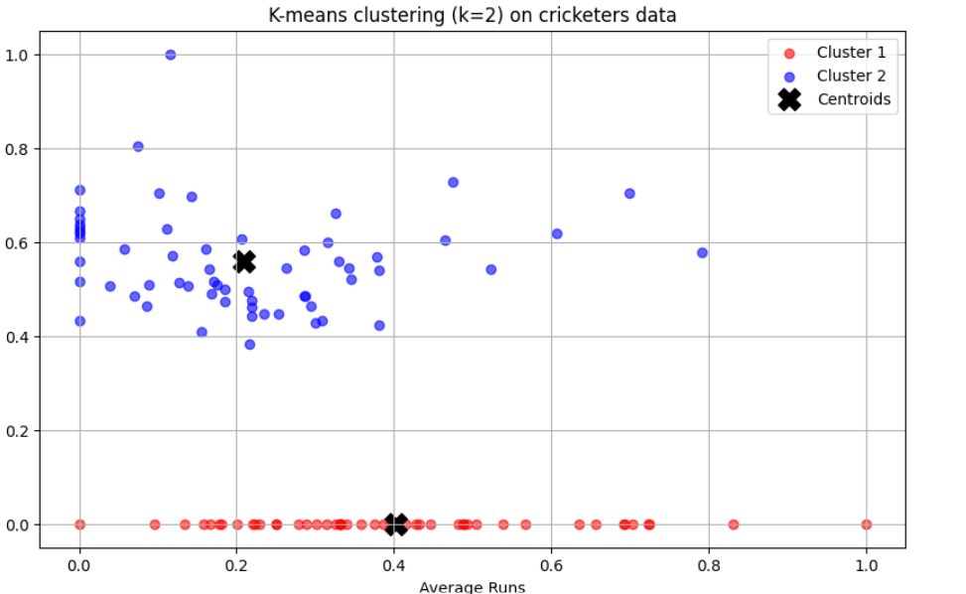

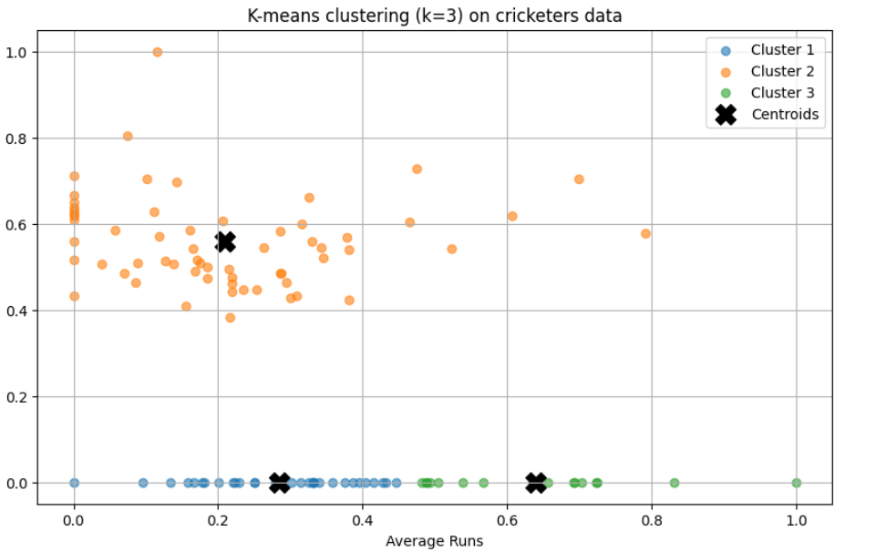

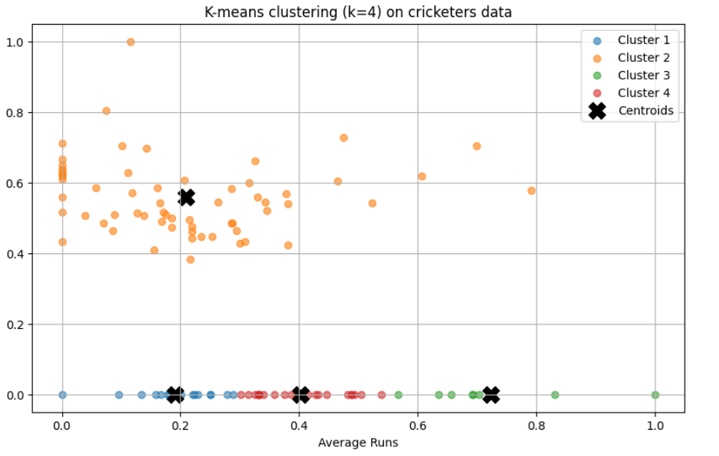

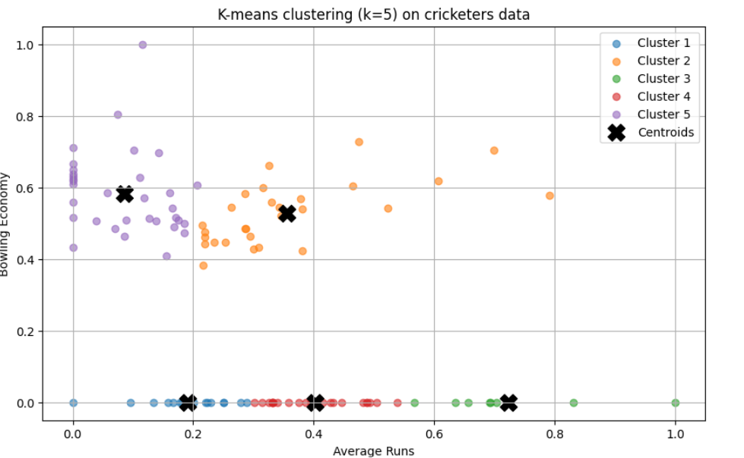

Based on the visualizations provided, here's a comparison of the different clustering:

**K = 2:**

* **Pros:** Simple and clear separation of the data into two distinct groups.
* **Cons:** Might be too simplistic, potentially losing important nuances within the data.

**K = 3:**

* **Pros:** More nuanced separation than k=2, potentially identifying subgroups within the data.
* **Cons:** Some overlap between clusters, suggesting potential misclassification.

**K = 4:**

* **Pros:** Even more detailed separation than k=3, potentially revealing finer-grained patterns.
* **Cons:** One cluster appears to be very small, which might not be statistically significant.

**K = 5:**

* **Pros:** Very detailed separation, potentially identifying very specific subgroups.
* **Cons:** Several clusters appear to be very small, which might not be statistically significant. Overfitting is a potential risk.

**Overall, based on visualization only, K = 3 seems to be a good compromise between simplicity and detail.** It provides a reasonable separation of the data without overfitting. However, it's important to note that this is a subjective evaluation based on visual inspection.

To make a more definitive decision, it's recommended to use statistical techniques like the elbow method or silhouette analysis to assess the quality of the clustering.

**Question 4: -**

**Write a few lines in a word document about the interpretation of the best clusters obtained. Also write a few statements about how these clusters can be useful.**

**Answer: -**

Interpretation of Cricketers Clusters

Interpretation of the Best Cluster:

Based on the visualization, the clustering with K=3 appears to provide the most meaningful separation of cricketers into distinct groups.

* Cluster 1: This cluster likely represents all-rounders or batting all-rounders, characterized by a balance of batting and bowling abilities.
* Cluster 2: This cluster likely represents specialist batsmen, characterized by high average runs and lower bowling economy.
* Cluster 3: This cluster likely represents specialist bowlers, characterized by low bowling economy and lower average runs.

Potential Use Cases of the Clusters:

* Player Selection: Teams can use these clusters to identify players who complement each other's strengths and weaknesses. For example, a team might want to select players from different clusters to create a well-rounded squad.
* Player Development: Coaches can use these clusters to identify areas where players need to improve. For example, a player in Cluster 2 might need to improve their bowling skills to become a more versatile player.
* Team Strategy: Teams can use these clusters to develop specific strategies for different types of opponents. For example, a team might adopt a more aggressive batting approach against teams with a strong bowling attack (Cluster 3).
* Fantasy Cricket: Fantasy cricket players can use these clusters to identify potential value picks and avoid overvalued players.

By understanding the characteristics of each cluster, teams, coaches, and fans can make more informed decisions about player selection, development, and strategy.